|  |  |  |
| --- | --- | --- |
|  | | |
| BuNest App  Software Engineering Project Report | | |
| MOEEZ MUSTAFA (01-134212-088) |  | MUJADIL HAZQEEL (01-134212-177) |

Abstract

Our project introduces an innovative mobile application, "BuNest" designed as an Airbnb-inspired platform built using React Native. BuNest aims to streamline the reservation process for university classrooms, facilitating the scheduling of both regular lectures and makeup sessions.

The application offers a user-friendly interface, enabling professors, students, and administrators to effortlessly browse, select, and reserve available classrooms on their university campus. Leveraging the power of React Native, BuNest ensures a seamless and responsive cross-platform experience for users on iOS and Android devices.

Key Features:

1. Classroom Listings:

2. Reservation Management:

3.User Profiles:

4. Real-Time Updates:

BuNest aims to enhance the efficiency of university resource utilization, providing a centralized platform for managing classroom reservations. By leveraging the flexibility of React Native, this application ensures a consistent and engaging experience for users, promoting effective communication and collaboration within the academic community.

Table Of Content:

|  |  |  |
| --- | --- | --- |
| Sno | Name | Page |
| 1 | Problem Statement | 3 |
|  | Process Model | 3 |
|  | Context Level diagram | 6 |
|  | SRS | 5 |
|  | Use Case | 8 |
|  | ER diagram | 12 |
|  | Sequence diagram | 12 |
|  | Timeline chart | 13 |
|  | Screenshots | 13 |
|  | Risk Analysis |  |
|  | Testing |  |
|  | Conclusion |  |

**PROBLEM STATEMENT**

Classroom reservation often involve cumbersome administrative processes, leading to scheduling conflicts, miscommunications, and underutilization of available spaces. This issue becomes more pronounced when accommodating both regular lectures and makeup sessions, requiring a dynamic and user-friendly solution.

Challenges:

Inefficient Reservation Systems: Existing methods of reserving university classrooms are often manual, time-consuming, and prone to errors, resulting in scheduling conflicts that disrupt the academic calendar.

Lack of Real-time Information: Current systems may not provide real-time updates on classroom availability, making it difficult for professors and students to find suitable spaces for impromptu makeup sessions or supplementary classes.

Communication Gaps: There is a lack of centralized communication channels for professors, students, and administrators to coordinate and share information about classroom reservations, leading to confusion and overlapping bookings.

Underutilization of Resources: Many classrooms remain unused during specific time slots, while others are overbooked, highlighting the need for a more balanced and optimized allocation of university resources.

**PROCESS MODEL**

BuNest App follows **INCREMENTAL** model because initially software requirements are reasonably well defined but the overall scope of development effort is a purely linear process. There may be other requirements of the user which will be known later. So, those requirements can the implemented and delivered in the following next increments. Our project is a short term project of 2 months and team member consist only two person.

**Introduction**

**Purpose:**

BuNest is developed with the primary purpose of providing an efficient and user-friendly platform for reserving university classrooms, focusing on both regular lectures and makeup sessions. The system aims to streamline the reservation process, optimizing the utilization of university resources and minimizing scheduling conflicts. By fostering improved communication among professors, students, and administrators, BuNest enhances the overall user experience with features such as real-time updates, and personalized user profiles.

**Scope:**

BuNest is developed with the primary purpose of providing an efficient and user-friendly platform for reserving university classrooms, focusing on both regular lectures and makeup sessions. The system aims to streamline the reservation process, optimizing the utilization of university resources and minimizing scheduling conflicts. By fostering improved communication among professors, students, and administrators, BuNest enhances the overall user experience with features such as real-time updates, a review and rating system, and personalized user profiles

**System Requirement Specifications**

**Functional Requirements:**

**User Registration and Authentication:**

Users should be able to create accounts with a valid university email address.

The system should authenticate users securely, ensuring data privacy.

**Responsive Design:**

The UI should be responsive, providing a seamless experience across different devices, including desktops, tablets, and mobile phones.

**Classroom Listings:**

The platform should display a comprehensive catalog of available university classrooms.

Classroom details should include capacity, available equipment, and location information.

**Reservation Management:**

Users (professors, students, and administrators) should be able to browse and reserve classrooms for regular lectures and makeup sessions.

A calendar view should allow users to identify and select available time slots.

**Real-Time Updates:**

The system should provide real-time updates on classroom availability to prevent conflicts.

Users should receive notifications for reservation confirmations, changes, or cancellations.

**User Profiles:**

Users should have the ability to create, update, and manage their profiles.

User profiles should display reservation history and preferences.

**Non-Functional Requirements:**

**Performance:**

The system should provide a responsive user experience with minimal latency.

It should handle a concurrent user load equivalent to the peak usage times at the university.

**Security:**

User authentication and data transfer should be encrypted to ensure the security of user information.

The system should have mechanisms in place to prevent unauthorized access.

**Scalability:**

The platform should be designed to scale with growing user and classroom data.

It should accommodate future enhancements without significant reengineering.

**Compatibility:**

The application should be compatible with major web and mobile devices (iOS, Android).

**Regulatory Compliance:**

The system should adhere to data protection regulations and university policies.

It should comply with relevant legal and ethical standards.

**DATA FLOW DIAGRAM:**

**Context Level Diagram:**

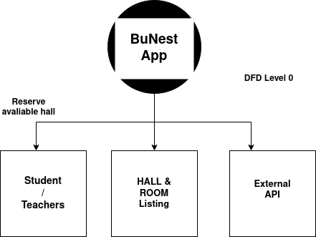**Level 0 DFD**

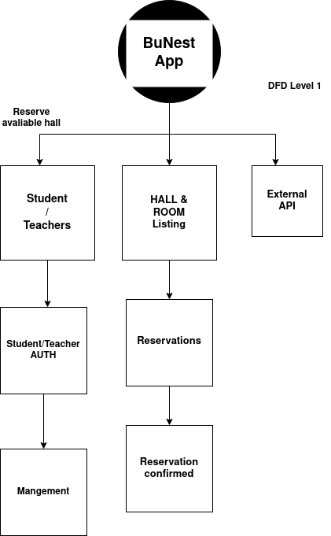**DFD Level 1**

**USE CASE**

**Diagram:**

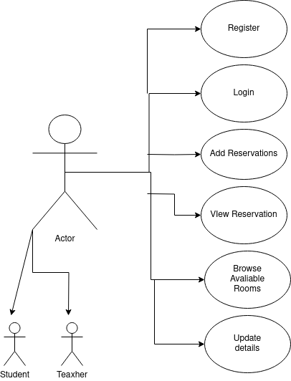 **use case diagram**

**Use Case Description:**

**Register:**

Use Case ID: UC-01

Use Case Name: Register

Actors:

User (Guest)

Description: The "Register" use case (UC-01) represents the process through which a new user (Guest) creates an account on the BuNest App. This use case involves providing necessary information for account creation and includes validation steps to ensure accurate and secure registration.

Preconditions:

The user is not currently registered in the BuNest system.

The user accesses the registration page.

Basic Flow:

The user accesses the registration page on the BuNest system.

The system prompts the user (Guest) to provide necessary information, including a valid university email address, a password, and user type selection (professor, student, or administrator).

The user enters the required information and submits the registration form.

The system validates the provided information, checking for the correctness of the email format, password strength, and user type selection.

If the information is valid, the system creates a new user account and sends a verification email to the provided university email address.

The user receives the verification email and clicks on the provided link to confirm and activate the account.

After successful verification, the system confirms the registration (UC-01) and redirects the user to the login page.

Alternative Flow:

If the provided information is not valid (e.g., invalid email format, weak password), the system prompts the user to correct the errors and resubmit the registration form.

Postconditions:

A new user account is created in the BuNest system.

Exceptional Conditions:

If the user does not Register, the system allows them to contact support.

**Add Reservation**

Use Case ID: UC-03

Use Case Name: Reserve Classroom

Actors:

User (Professor or Student)

Description: The "Reserve Classroom" use case (UC-03) involves the process through which a registered user (Professor or Student) reserves a university classroom for either a regular lecture or a makeup session. This use case enables users to browse available classrooms, select a suitable time slot, and confirm their reservation.

Preconditions:

The user is registered and logged into the BuNest App.

The user has navigated to the reservation section of the system.

Basic Flow:

The user logs into the BuNest system and navigates to the reservation section.

The system displays a list of available classrooms with details such as capacity, equipment, and location.

The user browses the available classrooms and selects a specific classroom for reservation.

The user chooses a date and time for the reservation from an interactive calendar view.

The system validates the selected date and time for availability, ensuring there are no scheduling conflicts.

If the selected slot is available, the user confirms the reservation.

The system updates the database with the reservation details, marking the selected classroom as booked for the specified date and time.

The user receives a confirmation notification with the reservation details.

Alternative Flow:

If the selected slot is not available due to a scheduling conflict, the system notifies the user and prompts them to choose an alternative date or time.

Postconditions:

The selected classroom is reserved for the specified date and time.

The user receives a confirmation notification.

Exceptional Conditions:

If the user encounters an issue during the reservation process, they can contact customer support for assistance.

**Browse Room:**

Use Case ID: UC-05

Use Case Name: Browse/Select Properties

Actors:

User (Professor or Student)

Description: The "Browse/Select Properties" use case (UC-05) involves the process through which a registered user (Professor or Student) explores available university classrooms, reviews their details, and selects a specific classroom for potential reservation within the BuNest system.

Preconditions:

The user is registered and logged into the BuNest system.

The user has navigated to the section for browsing and selecting available classrooms.

Basic Flow:

The user logs into the BuNest system and navigates to the section for browsing and selecting available classrooms.

The system displays a comprehensive catalog of university classrooms, highlighting details such as capacity, available equipment, and location.

The user utilizes search and filter functionalities to narrow down the list of available classrooms based on specific criteria.

The system presents the user with a list of filtered classrooms, each accompanied by relevant information.

The user reviews the details of various classrooms, including capacity, equipment, and location, to make an informed decision.

The user selects a specific classroom of interest for potential reservation.

Alternative Flow:

If the user has a specific classroom in mind, they may use a direct search option to locate and select that classroom.

Postconditions:

The user has reviewed available classrooms and selected a specific classroom of interest.

Exceptional Conditions:

If the user encounters difficulties in finding suitable classrooms, the system provides assistance through search and filter functionalities or prompts the user to contact customer support.

**ER Diagram:**

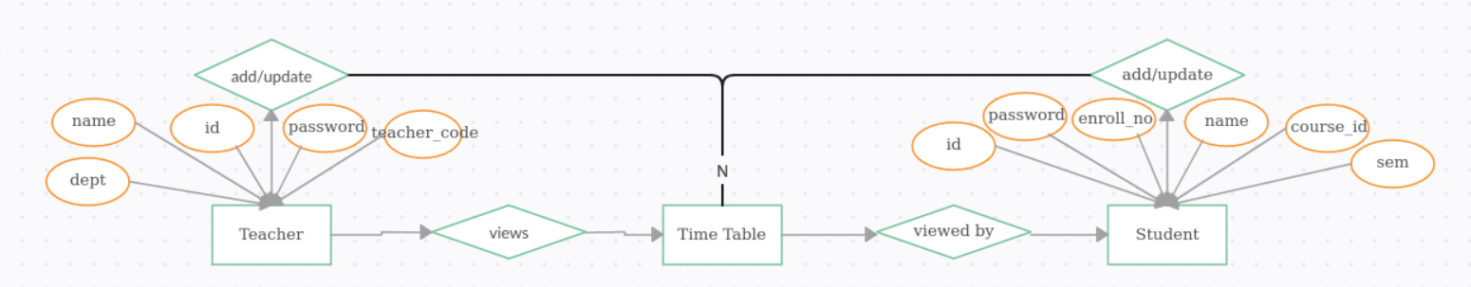

**Sequence Diagram**

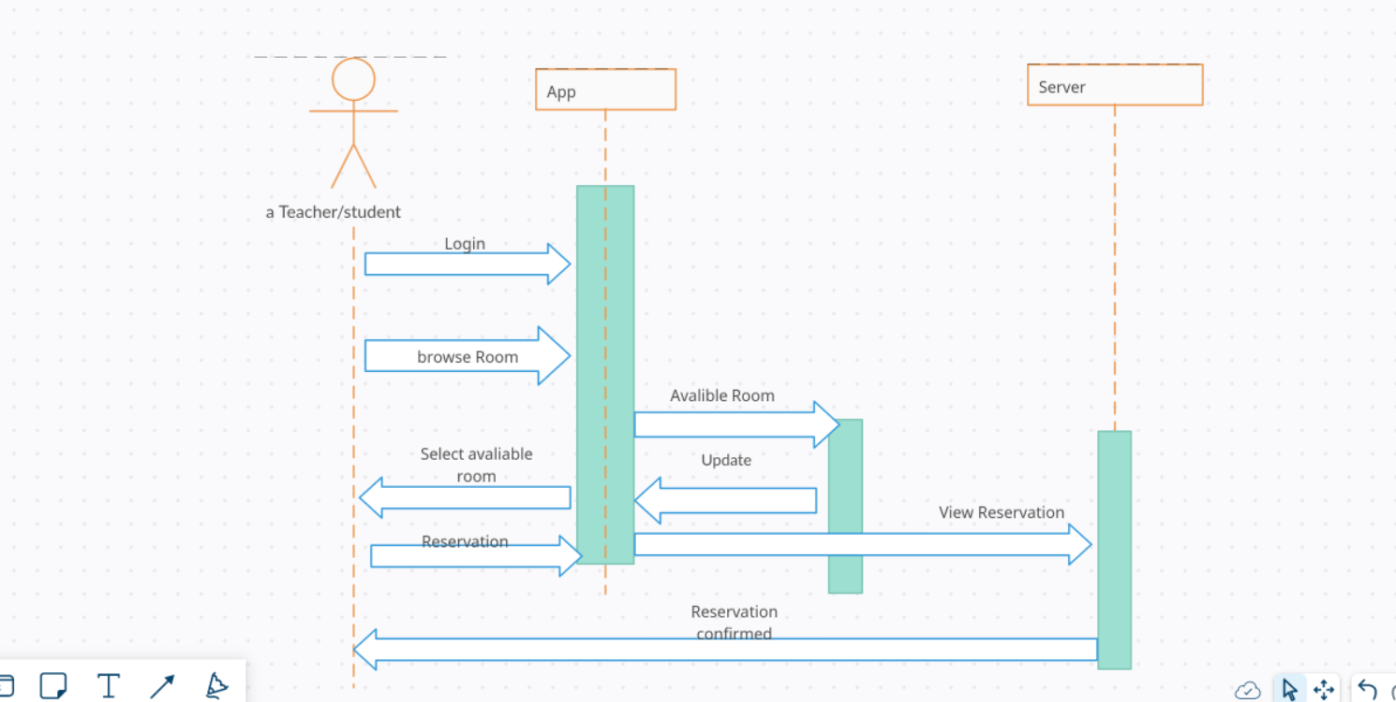

**TimeLine Chart**

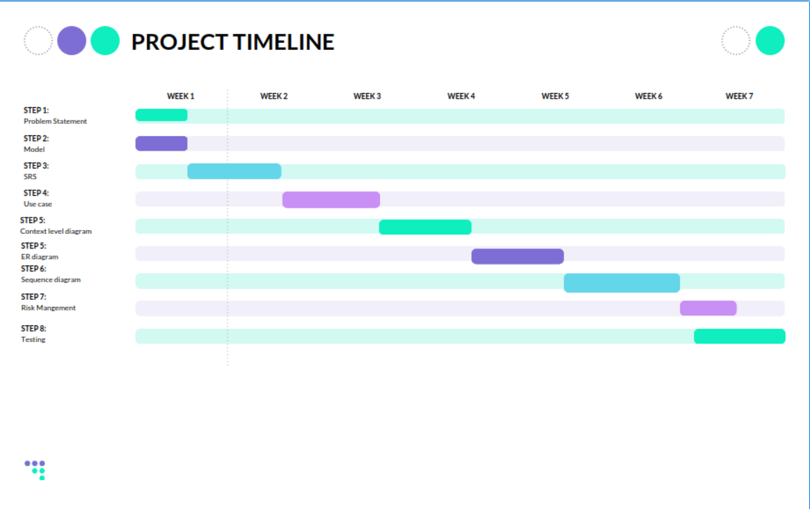

**SCREENSHOTS**